**Assignment – 3**

**NAME – PRAGATI SOLEY**

**PRN – 2020BTECS00084**

**BATCH – T8**

* **Create a project (give name of your project) in Jira, use template as Scrum and add your team members into this project**

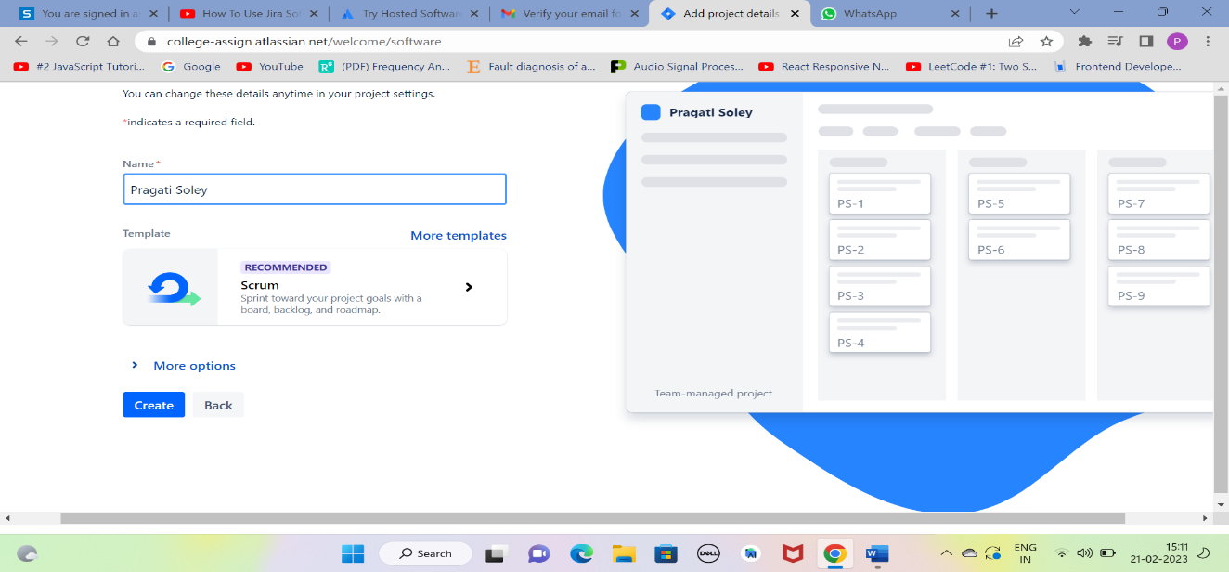

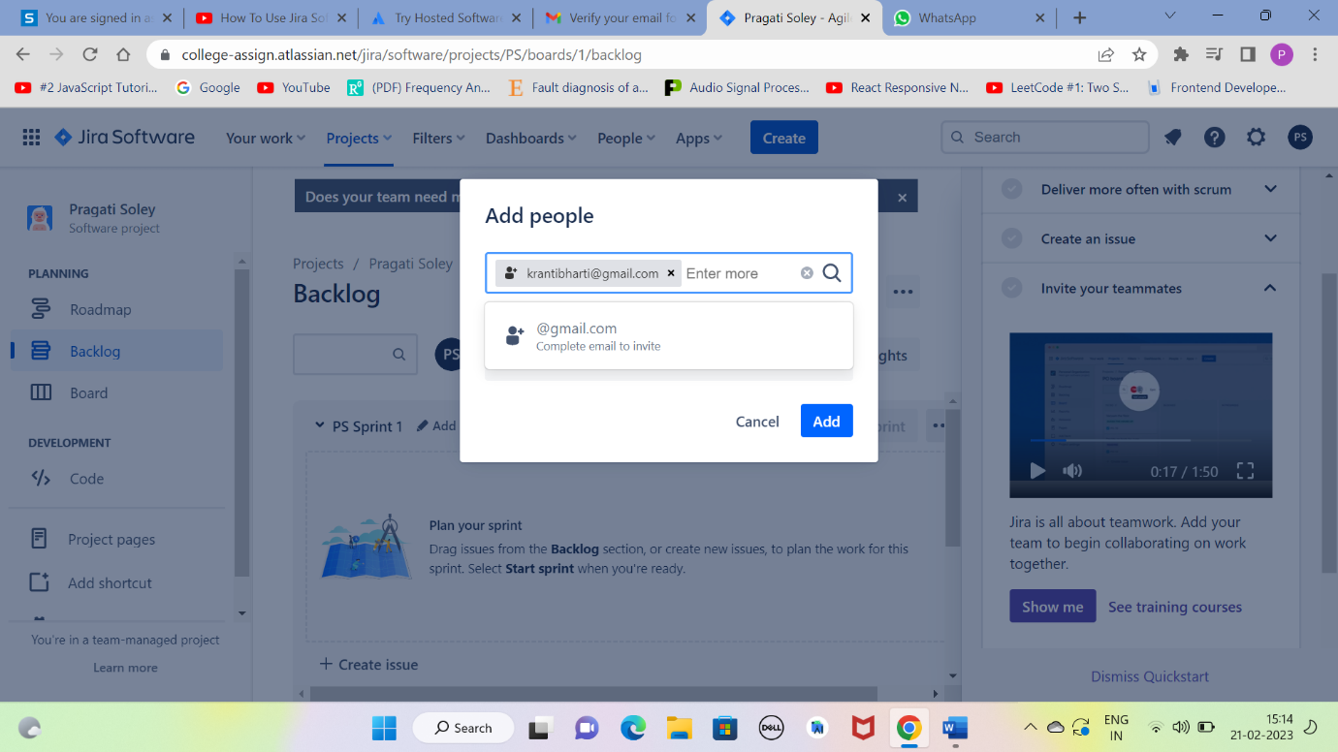

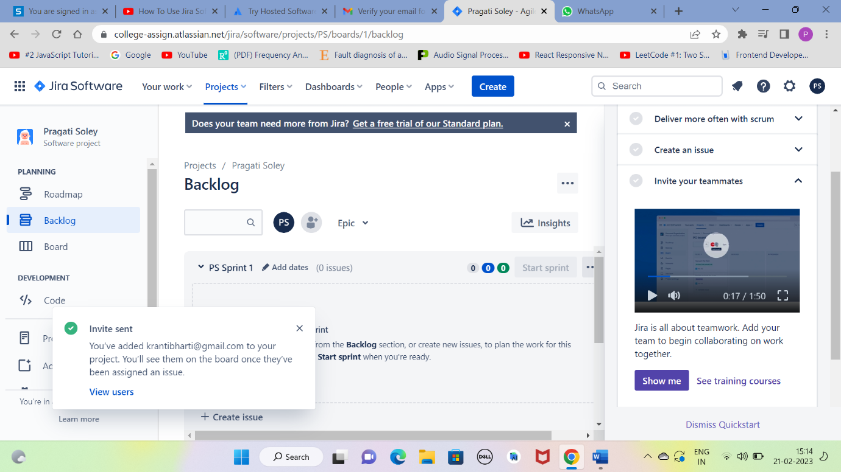

* **Create an Epic into above project (main requirement of your project, e.g Creating a web application for student result generation).**

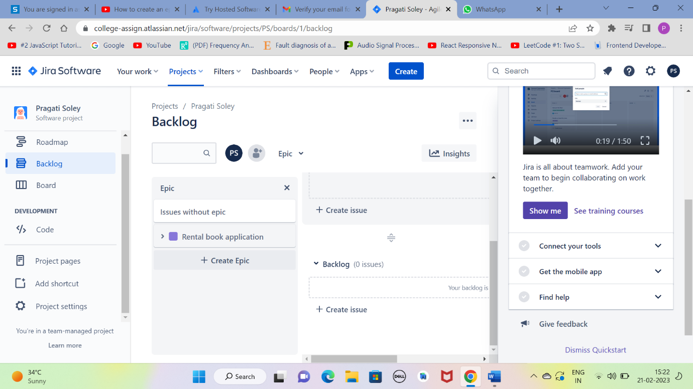

* **Create at least 5 user stories with respect to above epic for your project.**

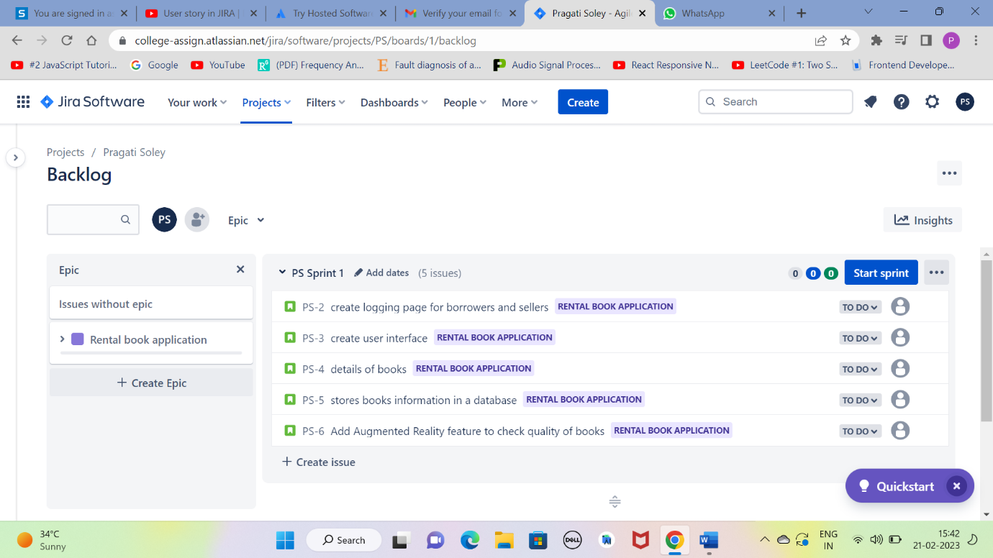

* **Create at least 2 subtasks for every user story. Assign user stories to your team members.**

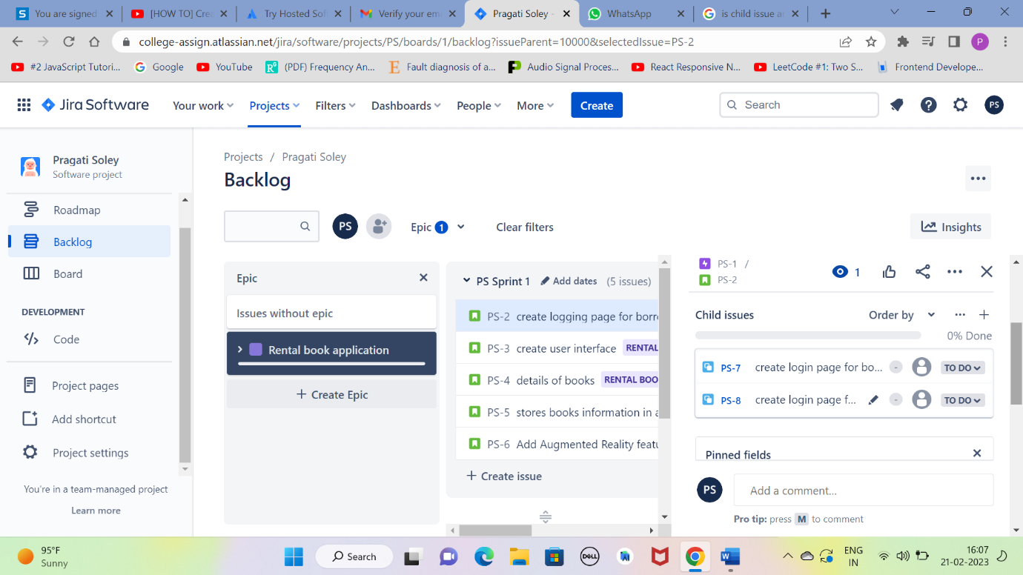

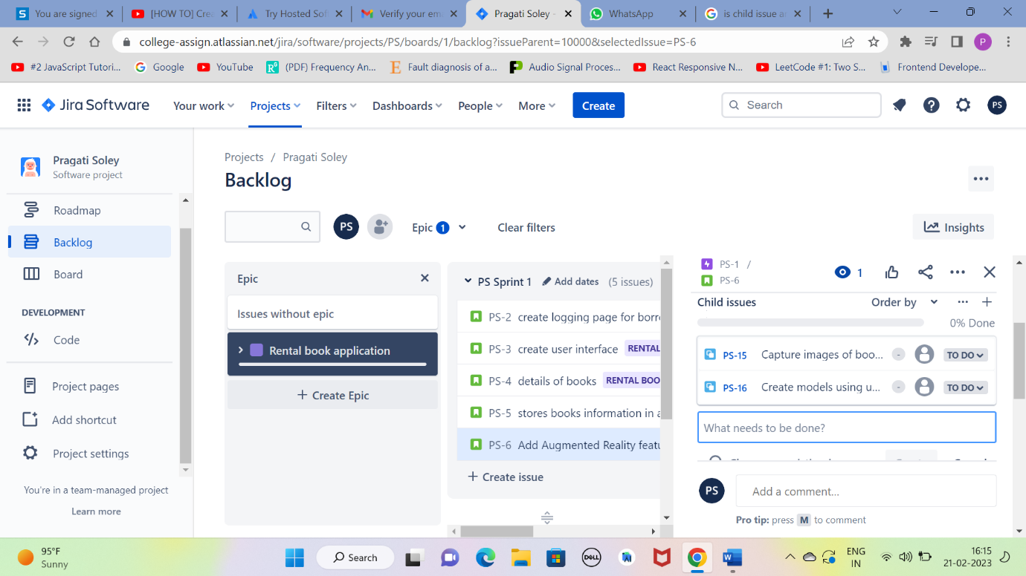

* **Create sprints for every use story and prioritize them according to your tasks. Assign time period for every user story.**

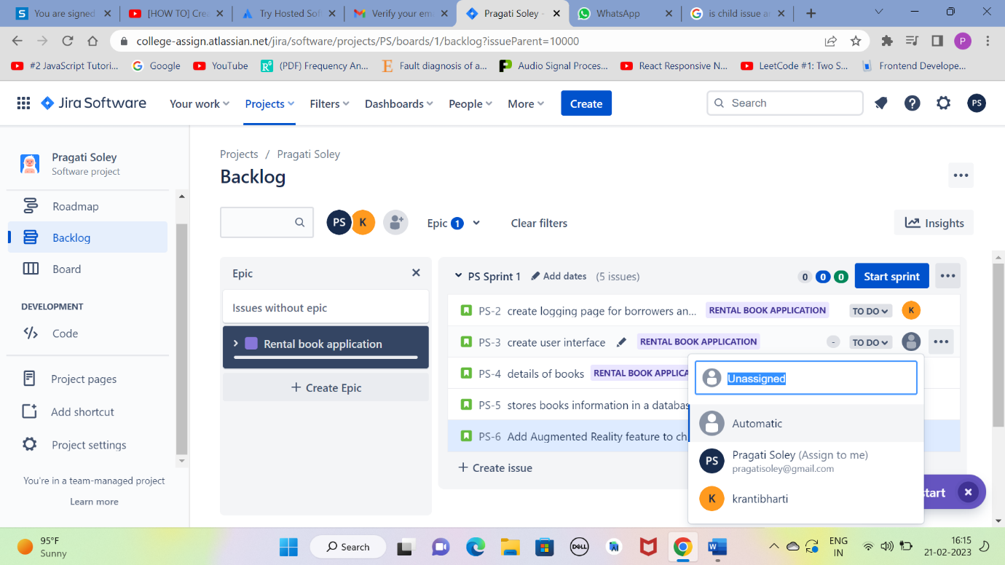

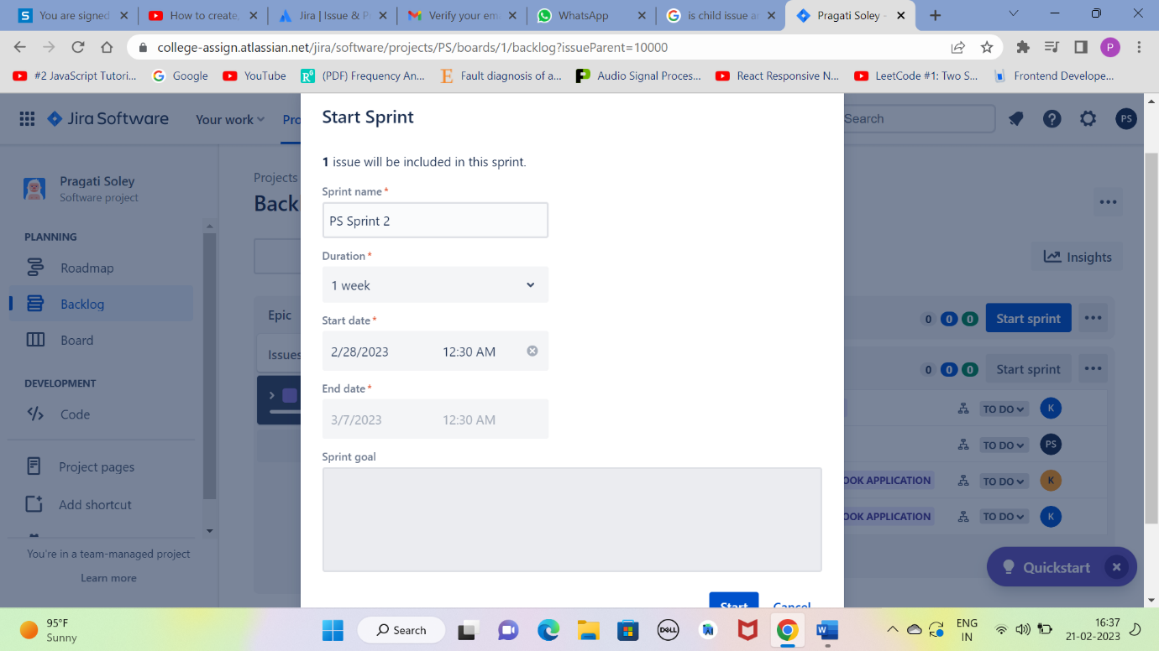

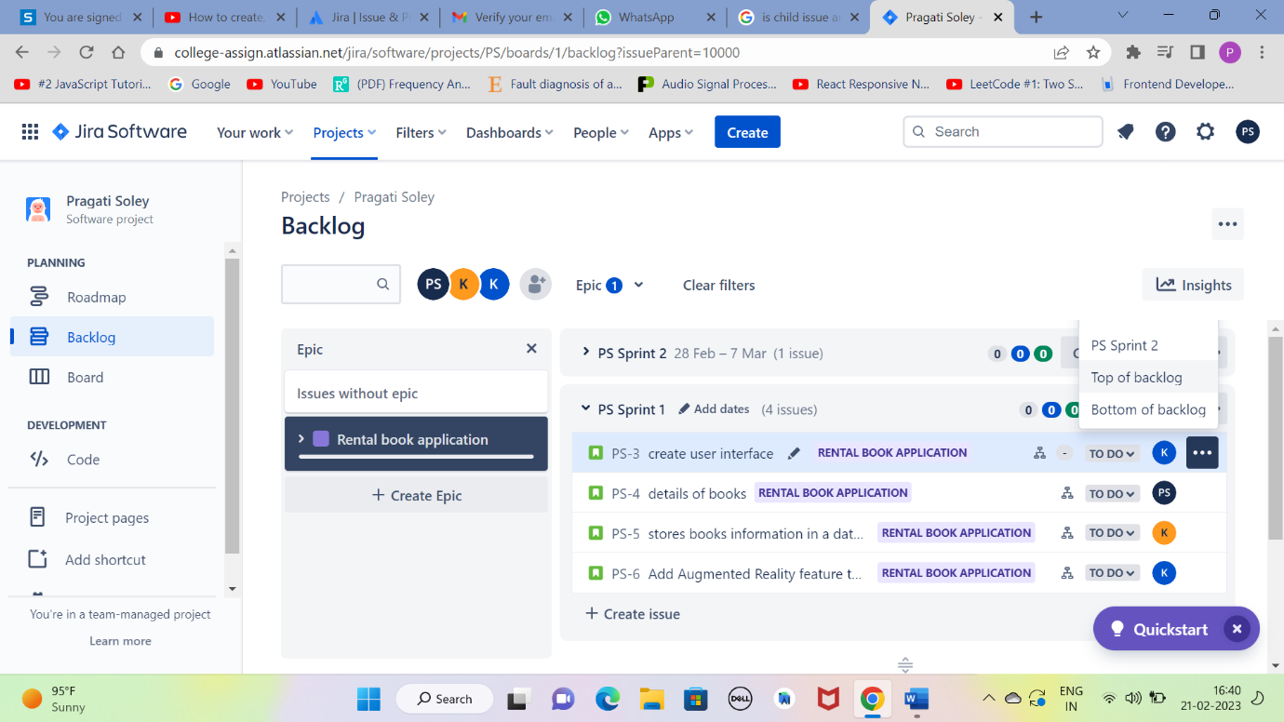

* **Update the status of some user stories as To Do, In Progress or Completed according to sprints (add appropriate comments).**

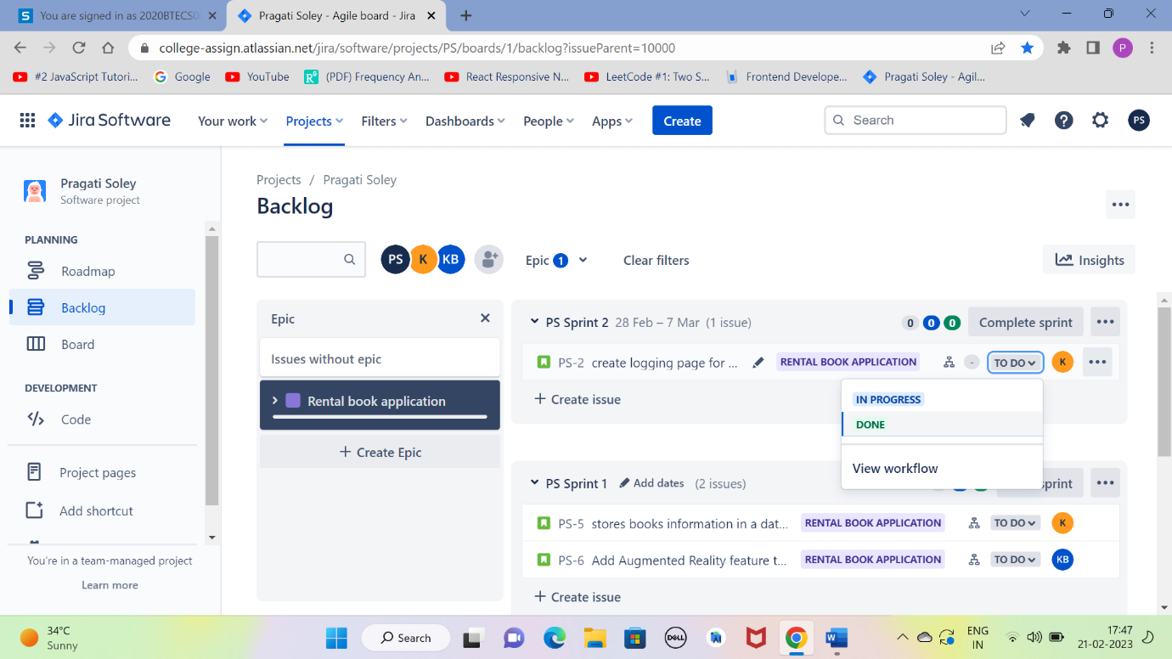

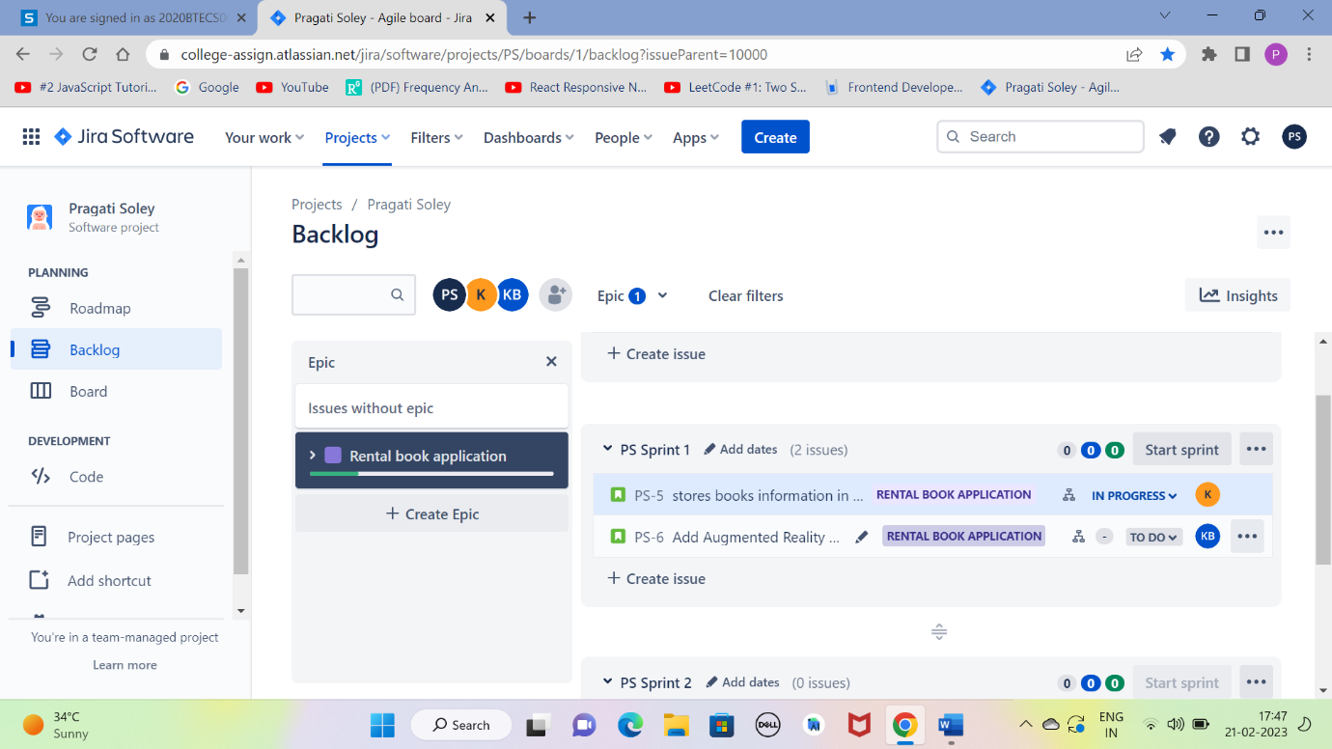

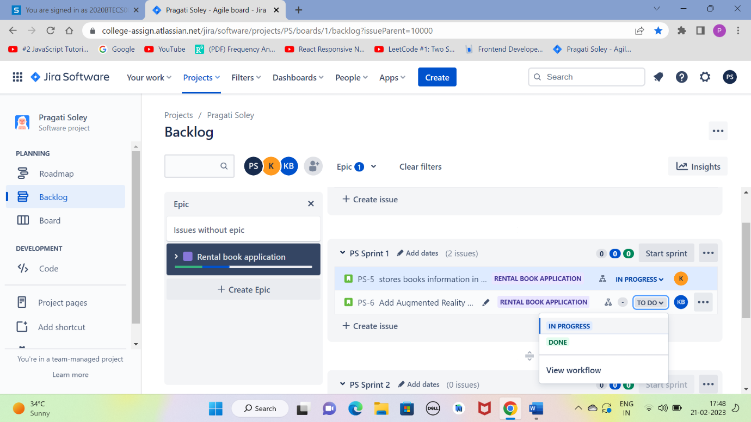

* **Create a bug/issue for respective user story and epic and assign to respective member.**

